**Practicing Landings Notes**

**Lesson 1: Ground Reference Maneuvers**

* If the airplane is subjected to any crosswinds, it will drift off course in the wind’s direction.
* You must angle the plane into the wind to counteract it and fly straight.
* **Crab angle:** The angle that the plane’s nose is pointed upwind of its ground track to compensate for crosswinds.
* **The Course:** The line drawn on an aviation chart to be flown.
* **The Heading**: The direction that the nose of the plane is pointed.
* **The Track**: The path that the plane is actually travelling through on the ground.
* If the course and track are the same the planes heading is correct.
* **Ground Reference Maneuvers:** Help to recognize and correct for wind while staying on course and scanning for air traffic. Typically flown at lower altitudes, 600 – 1000 ft
  + **Rectangular courses**
  + **S-turns**
  + **Turns around a point**
* Wind Indicators on the ground include smoke, and swaying tress, water, grass.
* All maneuvers must comply with the Federal Aviation Regulations (FAR) for Minimum Safe Altitudes FAR 91.119.
  + **(a)** ***Anywhere.*** An altitude allowing, if a power unit fails, an emergency landing without undue hazard to [persons](https://www.law.cornell.edu/definitions/index.php?width=840&height=800&iframe=true&def_id=0dc5e415556e65322f1454c927515578&term_occur=999&term_src=Title:14:Chapter:I:Subchapter:F:Part:91:Subpart:B:Subjgrp:4:91.119) or property on the surface.
  + **(b)** ***Over congested areas.*** Over any congested area of a city, town, or settlement, or over any open air assembly of persons, an altitude of 1,000 feet above the highest obstacle within a horizontal radius of 2,000 feet of the [aircraft](https://www.law.cornell.edu/definitions/index.php?width=840&height=800&iframe=true&def_id=8e9caab04f792d93d0738c9d3290164e&term_occur=999&term_src=Title:14:Chapter:I:Subchapter:F:Part:91:Subpart:B:Subjgrp:4:91.119).
  + **(c)** ***Over other than congested areas.*** An altitude of 500 feet above the surface, except over open water or sparsely populated areas. In those cases, the [aircraft](https://www.law.cornell.edu/definitions/index.php?width=840&height=800&iframe=true&def_id=8e9caab04f792d93d0738c9d3290164e&term_occur=999&term_src=Title:14:Chapter:I:Subchapter:F:Part:91:Subpart:B:Subjgrp:4:91.119) may not be operated closer than 500 feet to any [person](https://www.law.cornell.edu/definitions/index.php?width=840&height=800&iframe=true&def_id=0dc5e415556e65322f1454c927515578&term_occur=999&term_src=Title:14:Chapter:I:Subchapter:F:Part:91:Subpart:B:Subjgrp:4:91.119), vessel, vehicle, or structure.
  + **Stadium TFR Notam:** No operations within 3,000 ft AGL and 3NM of a stadium event from 1hour before to 1hour after.
* **Rectangular Course**
  + Select a rectangular field with road or tree line boundaries between 0.5 – 1 mile across.
  + Turn left into a right-hand traffic pattern at a 45 $°$ entrance.
  + Make medium turns to the right in the traffic pattern with the boundaries far enough to be in sight around the mid-wing section of the plane.

**Lesson 3: Engines**

* Engines lose power as the plane gains altitude due to lowering of air density.
* The fuel air mixture will become richer at higher altitudes if settings are not changed.
* Over rich fuel air mixture can cause spark plug fouling and more wear on the engine components.
* **Leaning:** Reducing the fuel mixture as you gain altitude to keep the engine from running roughly and save fuel.
* At cruise, the exhaust gas temperature (**EGT**) gauge is used for leaning at 80% power or less.
  + **Warning:** Leaning at higher power settings can damage the engine
* Lean the engine until the EGT reaches a maximum; then record that setting for later reference.
  + Recommended cruise setting is usually 50 $°$ rich of peak EGT
  + The best fuel economy keep the engine at peak EGT
  + Mixture must be reset with any changes in altitude or power
* Always climb at full power and full rich setting
* **Detonation:** An excessive and damaging explosion in the piston cylinder of the engine which typically affects all cylinders.
  + Usually caused by and incorrect grade of fuel or too lean of a mixture at a high-power setting.
* **Preignition:** Ignition of the fuel air mixture in a cylinder before the completion of the compression stroke in the engine.
  + Typically caused by excessive heating of components in the cylinder such as the sparkplugs or valves.
  + Noticeable as a loss of power from the engine.
* Both can be reduced by increasing cooling in the engine by increasing airspeed or opening the cowling flaps, and reducing power and enriching the mixture.

**Lesson 5: Aerodynamics**

* The basic four forces acting on a plane are **Lift, Weight, Thrust, and Drag**
* **Steady Level Flight:** Thrust = Drag and Lift = Weight

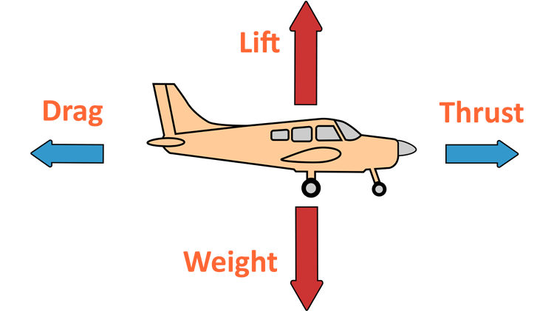

* **Drag:** The rearward retarding force on the plane and is typically separated into two types.

1. **Induced Drag:** Caused by the lift generated by the wings of the plane.

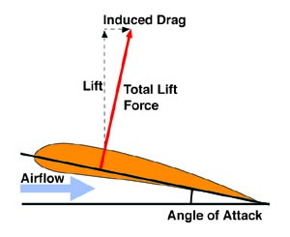

1. **Parasite Drag:** Made by the air that contacts the fuselage and any protruding pieces of the plane.

* If airspeed increases the forward forces are greater than the rearward forces on the plane in vice versa.
* **Angle of Attack (AOA):** The angle between the chord line of the wing and the relative wind of the plane.
  + **Warning:** This is different from the pitch angle of the plane. A plane climbing may have a lower angle of attack than the same plane in level flight.
* **Stall:** When the angle of attack is too high and air flow over the wing separates leading to complete loss of lift and sharp increase in drag.
  + A plane can stall at any speed and any attitude.

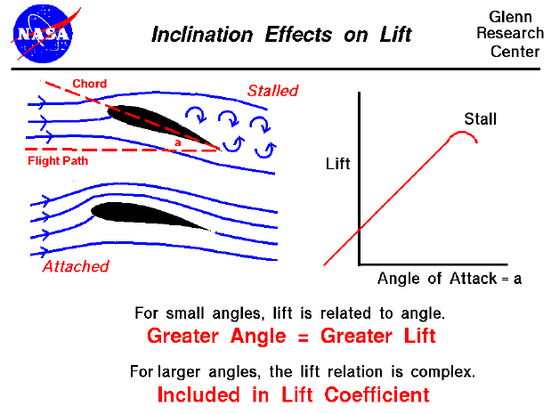

* **Critical AOA:** The angle of attack at which the plane will stall.
* **Trailing (Wing Tip) Vortices:** At the wing tip high-pressure and low-pressure air around the wing connect to create a powerful vortex that continues behind the plane.

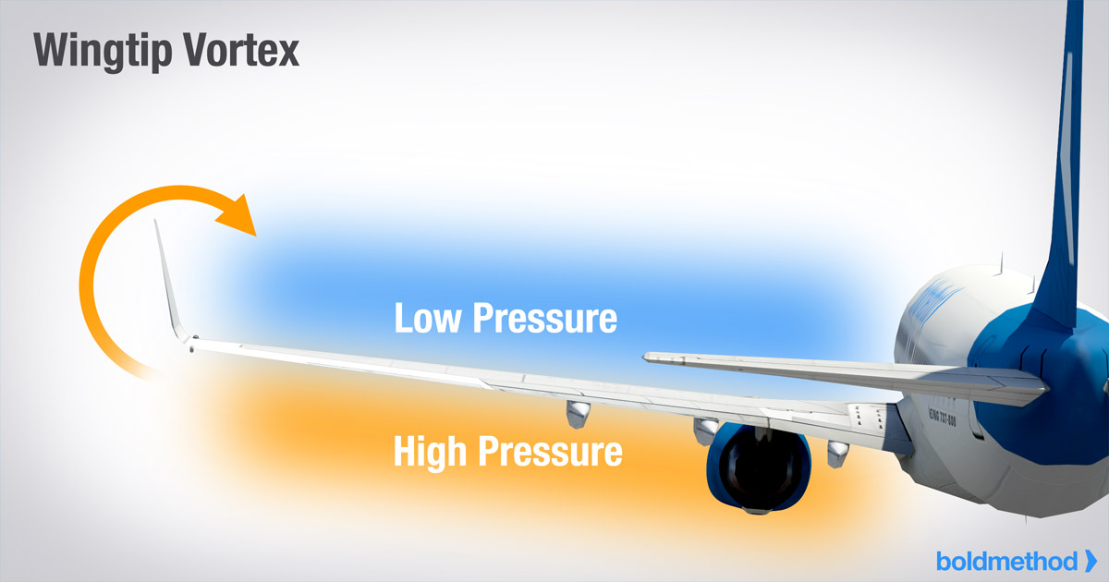

* **Center of Lift:** The point where most of the lift on the wings of a plane acts.
  + Typically, this is around the front quarter chord length of the wing.
  + Increase of angle of attack will move the center of lift forward on the wing.
* **Minimum Controllable Airspeed:** Airspeed at which the angle of attack of the plane is high enough that any reductions in speed, power or change in maneuver will force a stall.
* **Washout:** Wings are usually twisted from root to tip to have root stall before the tip to allow the ailerons to stay effective before a complete stall occurs.

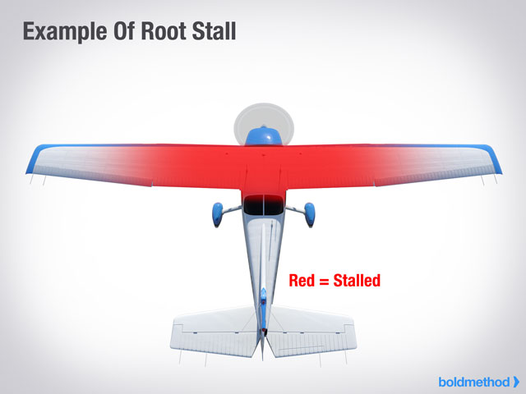

* **Spanwise Airfoil Variation:** When a different type of airfoil cross section is used at the root of the wing than the tip.
  + Typically, a high-speed airfoil at the root and low-speed airfoil at the tip.
* **Engine Torque:** Engines spin clockwise from the pilot’s view, which leads to force in the opposite spinning direction at low-speeds and high-power setting.
  + At low-speeds this makes the left wheel under more weight during take off and rolls the plane to the left.
* **Spiraling Slipstream (Corkscrew Effect):** Propeller causes air to spin around the plane and hit the rear stabilizer, making the plane yaw to the left.
  + Happens at low airspeed and high propeller speeds.
* **Gyroscopic Precession:** Any forces acting on the propeller act at a 90 $°$ angle in the direction of motion.
  + This is most noticeable on taildragger planes as they takeoff during which there is a top force rotating the plane nose down.
* **P-Factor:** At high angles of attack the descending blade side of the propellor produces more thrust than the ascending side leading to a left yaw action.
  + On muti-engine propeller driven planes this leads to one engine being more dangerous to lose than the other called the critical engine.

**Lesson 6: Angle of Attack**

* **Flight Path Angle:** The angle between the velocity of the plane and the horizon.
  + This is where the plane is really going in 3D space.
  + In a climb the flight path angle is positive.
* Most planes don’t have an angle of attack indicator so using an airspeed chart can give aa rough measurement.
* In steep turns and other maneuvers the plane can stall at higher speeds given the need for higher pitch.

**Lesson 7: Slow Flight**

* Slow flight training helps develop skills for stall detection and recovery during maneuvers.
* The slower the plane flies the more the AOA must increase to maintain altitude.
* **The Drag Polar:**

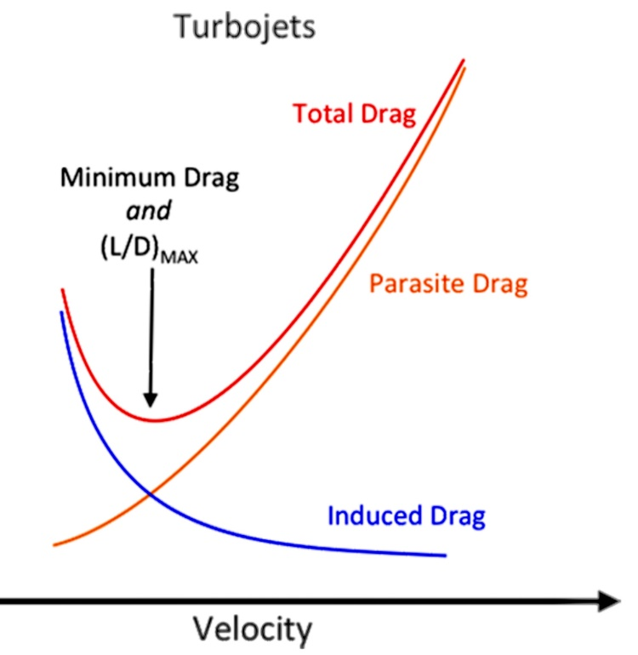

* + As speed increases induced drag decreases but parasite drag increases.
  + The lowest point of drag is the speed for maximum endurance of the plane.
  + Behind the max endurance point is the “back side of the power curve” or Region of Reverse Command. An increase in thrust is needed to maintain altitude in this range.

**Slow Flight Procedure:**

1. Be at least 1,500 ft above ground level (**AGL)**
2. Perform pre-maneuver checklist and clearing turns
3. Reduce power to 500 rpm below the power need to fly slow at steady level flight.
4. Pull back on controls and increase pitch to maintain altitude and trim
5. When the plane is within 5 knots of the desired speed increase power and retrim.
6. Use rudder to counteract left turning tendencies of the plane.
7. Add flaps if desired.
8. If the stall warning engages pitch down slightly.
9. To exit slow flight, add full power, retract flaps, and pitch up to compensate for any loss of lift.

* Only perform maximum medium turns in slow flight
* If turning add power and change pitch to maintain speed and altitude
* Flaps lower the stalling speed.

**Lesson 9: Stalls**

* **Stalls are caused by Excessive Angle of Attack**
  + Can occur at any power setting, attitude, or airspeed
* Practical test standards divide Stalls into two kinds

1. **Power-Off Stalls (**Approach to Landing Stalls**)**
2. **Power-On Stalls (**Departure Stalls**)**

* Student are required to recognize the first signs of a stall and take action to prevent or recover from it
* **Imminent Stalls Practice**: Recovery is initiated at the first sign of a stall
  + Purpose to avoid a full stall
* **Full Stall Practice:** Stall is allowed to fully develop before recovering
  + The stall progresses until full up elevator, nose down pitching, buffeting, and high sink rate
* **Warning:** A secondary stall can occur if pitch attitude is raised too high or too soon during recovery.
  + Release back elevator pressure to regain airspeed and then return to normal climb attitude when sped up.
* General aviation planes usually have wings that stall at an AOA of 16-18 $°$
  + Weight, bank angle, power setting, and load factor can change the speed at which the plane will stall.
* **Warning:** Stall recovery will include a loss of altitude
* ***Regulation*:** Stall recovery must be practiced and recovered from above 1,500 ft minimum.
* If a plane has a **Nose Heavy** CG, it will stall early
* If a plane has an **Tail Heavy** CG, it may be hard to recover from a stall

**Power-Off Stalls:**

* Typically, are done as Imminent stalls

1. Make two 90 degree clearing turns
2. Reduce power to idle and maintain altitude to slow plane to normal approach speed
3. Fully extend the flaps when in the white arc airspeed range
4. Slowly raise the nose to a climb pitch attitude
5. Start recovery when buffeting is felt around the plane
6. Lower the nose and add power to regain control surface effectiveness

**Power-Off Turning Stalls:**

* Should be performed at 20 $°$ to simulate a base leg turn to final
* Raise the nose of the plane to the stall pitch attitude to stall
* Keep the ball in the center to maintain altitude and coordination
* At the first sign of the stall lower the nose, add full power, level wings and add right rudder to counteract engine torque
* Slowly retract flaps and return to a specified attitude
* **For a full Stall:** Push the plane until it stalls and perform the proper
  + Perform the same steps as imminent stall recovery but also recover at a lower pitch attitude and enter the speed for best rate of climb after

**Power-On Stall:**

* Done straight ahead and in turns of 20 degrees
* Will have a higher pitch attitude and stall at a higher speed than the power-on
* Propellor slip stream maintains airflow over the center section s of the wings

1. Perform clearing turns and reduce power at constant altitude
2. Extend flaps if normally used for takeoff
3. Slow to rotation speed at constant altitude
4. Add full power and raise pitch for the normal takeoff
5. Use right rudder to maintain coordination
6. For **imminent stalls** maintain nose high pitch until the first feel of buffeting and lower pitch to just below level flight attitude.
   1. Retract flaps to increase airspeed if extended
7. For **Full Stalls** hold the elevator back until the nose drops or altitude is lost than push the nose down and retract flaps.

**Turning Power-On**

* Begin shallow bank turn up to 20 $°$ after lift-off speed is achieved
* P-factor and engine torque may cause the plane to roll
* Rudder should be used to keep the plane coordinated
* During recovery use the ailerons and rudder to prevent roll

**The factors that determine angle of attack of the plane:**

* **Airspeed**: lower airspeed = higher AOA
* **Weight**: higher weight = higher AOA
* **Load factor:** higher load factor = higher AOA

**Accelerated Maneuver stall:** Caused by excess load factors that occur in a sharp turning maneuver

1. Reduce power to 1.5x the normal stall speed
2. Enter a 45 degree turn while maintaining altitude
3. When at 20% normal stall speed increase back pressure to stall the plane
4. If plane starts to roll add full power release engine speed, and level wings

* **Warning:** If a stall happens while the ball is not centered (uncoordinated flight) it can result in a spin.

**Spin Escape Procedure:**

1. Reduce throttle to idle

2. Neutralize the ailerons

3. Apply rudder opposite of the spin

4. Wait for spinning to end and then perform stall escape maneuver

**Lesson 11: Normal Landings**

* 10 miles before you reach the airport call the Common Traffic Advisory Frequency or the local tower and state your position relative to the airport and intentions.
* A tower controller will assign an entry into the traffic pattern, a landing runway, and where to make the next radio call.
* **Traffic Pattern Entry (Recommended)**:
  + Always enter the traffic pattern while at traffic pattern height (typically 1000ft AGL)
  + Enter at 45 degree turn into the downwind leg (opposite the runway landing direction ) of the pattern around the midpoint of the runway side.
* **Traffic Pattern Entry (Alternate):**
  + Cross midfield 500 ft above the traffic pattern altitude (typically 1500ft AGL)
  + When far away from the pattern, descend to pattern altitude
  + Turn into a semi-circle to enter the pattern at the downwind 45 degree approach.

**Note:** You can also just cross the pattern and turn left 45 degrees onto the downwind leg if you have scanned the pattern and determined it is clear to do so. Give right of way to any aircrafts entering on the preferred side.

* **Traffic Pattern Entry (ATC Tower)**
  + Follow the controller’s instructions on how to enter the pattern
  + They can have you enter at downwind, base or final legs
  + They can also make you fly straight into a landing

**Prelanding Checklist:**

* Seat upright, seats and belts secured
* Fuel selector on both
* Mixture at full rich
* Landing light on

**Landing procedure:**

* After entering the pattern parallel to the runway perform the prelanding checklist
* Try to fly close enough to the runway to be able land in the event of a loss of power
* Slow the aircraft down to the flaps operating speed (**white arc**)
* Extend the flaps according to current training procedure (it depends on instructor and instructions)
* When the touchdown point looks about 45 degrees behind the wing of the plane, initiate the turn to the base leg while crabbing into the wind
* Wait until the plane is at a 45 degree angle from the runway (**Key point**)then make the turn from base leg to final
  + If you are too low make an immediate shallow turn to final
  + If you are too high delay the turn and make a medium one instead
* When aligned with the extended runway on final, select full flaps and pick an aiming point on the runway relative to a point on the windshield
* Descend along a glide slope towards the runway
  + If your aiming point goes above the reference, you are too low
  + If your aiming point goes below the reference, you are too high
* When the crosses the runway threshold and is the 10 to 20ft above it begin to round out
* Pull back on the aileron to flare the nose upwards and stall the plane just a few feet above the runway and land with the rear wheels first
* Call out a successful landing on the CTAF and then announce intentions to taxi away.
* Taxi to the parking area and announce when you are clear of the runway
  + At a towered airport exit through the first clear taxiway, announce to the controller, and await direction
* Follow the after landing and shut down checklists
  + Turn off requested lighting
  + Lean the mixture to for taxi (if the airport is high enough)
  + Retract the flaps
* Upon reaching the parking area
  + Turn off lights
  + Pull the mixture to idle cut off
  + When the propellor stops turn off the engine and master switch
  + Place the control lock on the yoke
  + Switch the fuel selector to one side
  + Stow away and secure the plane.

**Lesson 13: Takeoff & Landing Variations**

* If possible, take off into the wind for the safest and most viable climb out.
  + A 10% liftoff speed headwind can reduce takeoff distance by 19%
* **Left Crosswind Takeoff (6-9 Knots)**
  + Taxi onto the runway
  + Turn the yoke left so that left aileron is in full up position
    - This prevents crosswind from lifting the left wing
  + Add full take off power
  + Use the rudder pedals to steer the plane and keep it on the center line
    - Engine torque and weathervane tendency will cause the plane to turn towards the wind
  + Reach higher than normal takeoff speed and rotate
  + Let the plane side slip upon first taking off to compensate for the crosswind drift
  + After reaching high enough altitude crab into the wind and level the wings
  + Fly into the traffic pattern
* **Left Crosswind Landing**
  + Use 10 degrees of flaps on the downwind and base legs
  + Use 20 degrees of flaps on final leg
    - POH usually recommends using the minimum flaps necessary
    - You will have to trim to relieve certain pressures during descent
  + On final the crosswind will drift the plane to the downwind side
  + You can correct this with a crab or side slip maneuver
    - Crab maneuvers are easier to stay on the centerline but induce severe side loads on the gear if not done properly
    - Side slips require more skill but reduce the side loads on the gear
  + **Side slip maneuver:**
    - Lower the upwind wing and use opposite rudder
      * Drift is controlled with aileron and heading is controlled with rudder
      * If the plane drifts upwind off centerline reduce the sideslip
      * If the plane drifts downwind increase the sideslip
  + **Warning: If full rudder is not effective enough to produce a side slip the wind is too powerful! Choose a different runway more into the wind**
  + Crosswind effect typically diminishes as you approach the runway
  + Touch down on the upwind wheel
  + You can also crab and then side slip on the runway approach before the landing
* **Approaching the runway without flaps**
  + **On base leg make an appropriate turn:**
    - If you appear too high, turn slightly away from the runway
    - If you appear too low, turn in to the runway
  + Stall speed will be higher without flaps and the approach will be shallower
    - Expect a longer touchdown roll
  + Apply back pressure as you reduce power
  + Plane will float longer during the roundout
  + If you are too high on final lose altitude with a **Forward Slip:**
    - Orientation: Pointed at an angle to the flight path
    - Lower the wing on the side you want to slip
    - Yaw in the opposite direction with the rudder
    - Raise the nose as need to prevent airspeed loss
    - This is usually done with engine at idle

**Unusual landing scenarios**

* **Low final Approach:**
  + Add power and pitch up to increase lift
  + When back on good approach path set up attitude and adjust power to hold it
* **Slow final Approach:**
  + Add power to increase lift and reduce sink rate
  + Do a go around if the these are unrecoverable
* **Go Around:**
  + Add full power immediately
  + Change pitch to slow descent rate
  + Retract flaps to 20 degrees descent rate stops
  + Extend flaps again and climb
    - Be careful about manipulating the flaps to quickly or you could round out early or keep descending retract them one at a time
* **Rounding out too late**
  + Don’t flare to fast or you could land to hard
  + Add power and raise the nose high
    - If you can’t land in the first third of the runway, go around
  + Improper landing attitude and high sink rate will make the plane bounce
    - If it does add some power to cushion the next touch and adjust pitch to proper landing attitude
* **Warning:** Avoid hard landings or you could wreck the landing gear

**Lesson 14: Nontowered Airport Communications**

* Usually, a class E or G airspace
* May have pilots flying without a radio
* Always visually check and fly the traffic pattern for safety
* **Find the active runway**
* Try to check the local weather on radio to help with this
  + **AWOS:** Automated Weather Observing System
  + **ASOS:** Automated Surface Observing System
  + **AWSS:** Automated Weather Sensing System
  + Listen for winds and active runways
* Find the weather station radio station on a supplement chart of the airport or a gps sectional chart
* The system can also record notice to airman (NOTAM)
* Listen to the CTAF or UNICOM for pilot intentions and positions
  + Indicated by a radio frequency with a circled C at the end
  + Request landing advisory on the frequency
  + 2 miles away from runway call your entry into the downwind
  + Call in your turns to base and final and clearing of the runway
* Before landing set the transponder to squawk code VFR 1200 and set the mode to altitude.

**Departure Line Up Checks:**

1. Verify transponder is set to altitude mode
2. Announce departure intentions on CTAF
3. Scan one last time of traffic entering the runway
4. Taxi onto the runway for takeoff

* Saying “closed traffic” indicates that you will stay in the traffic pattern after takeoff
* **Standard Departure:**
  + Either directly outward or 45 degrees in the direction of pattern

**Lesson 15: Wake Turbulence Avoidance**

* Turbulence is caused by counterrotating vortices at the wingtips of a plane
* Large jet liners generate large enough wake turbulence to destabilize small G.A aircrafts.
* Vortices usually descend at a rate of 400-500 ft per minute and level off about 900 ft below the plane’s flight path
* **Taking off Behind a Large Airplane:**
  + Lift off prior to where the large plane rotated and turn into any crosswinds to avoid the wake turbulence
  + Try not to cross over a large airplane’s flight path
* **Landing After a Large Plane**
  + Stay above the planes flight path and touchdown further from where the large plane did
* **Landing on a Parallel Runway**
  + If the runway is less than 2500ft away from the one the large plane landed on, be aware of cross wind that can carry the vortices
  + Stay above the adjacent flight path and touch down after the other plane does.
* **Landing Behind a Large Departing Plane**
  + Land behind where the large plane took off
* **Landing on a Crossing Runway**
  + If landing on a runway that the large plane started flying over, try to land behind where the large plane crossed the runway or over its flight path
  + Go around if you can’t land in safely within that distance and wait for a few minutes
* Always adjust your flight path to avoid wake turbulence.
* Avoid flight above or below a large plane
* If a large plane is above you in flight move laterally into the wind to give it way
* Try to wait **3 minutes** before taking off or landing behind a large plane to let turbulence reduce